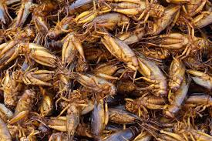
WORKSHOP 8: FOOD: THE GOOD, THE BAD, AND THE UGLY
Students will discover how personal eating habits and cultural preferences shape food choices
Fried cricket, anyone?

Comprehension: Compare / Contrast and Cause / Effect
Word Study: Synonyms and Suffixes
Conventions: Adjectives that Compare, Correcting Sentence Fragments

Vocabulary:
- Nutritious – healthy to eat
- Prefer – to like one thing more than another
- Appealing – to seem likable or interesting
- Satisfy – to please by giving what someone wants or needs
- Variety –a selection of different items
- Habit – an activity you do often without thinking
- Select – to choose
- Average – usual or ordinary
- Percent – part of a whole
- Adjust – to move or change something slightly
- Complex – with many parts
- Neglect – to fail to take care of someone or something
- Portion – an amount of food for one person
- Necessity – a strong need or requirement
- Source – where something comes from

