SKYWARD INVOICE ENTRY
Check requests, expense reimbursements, invoices can all be entered with the below directions.
- Accounts Payable>Invoice
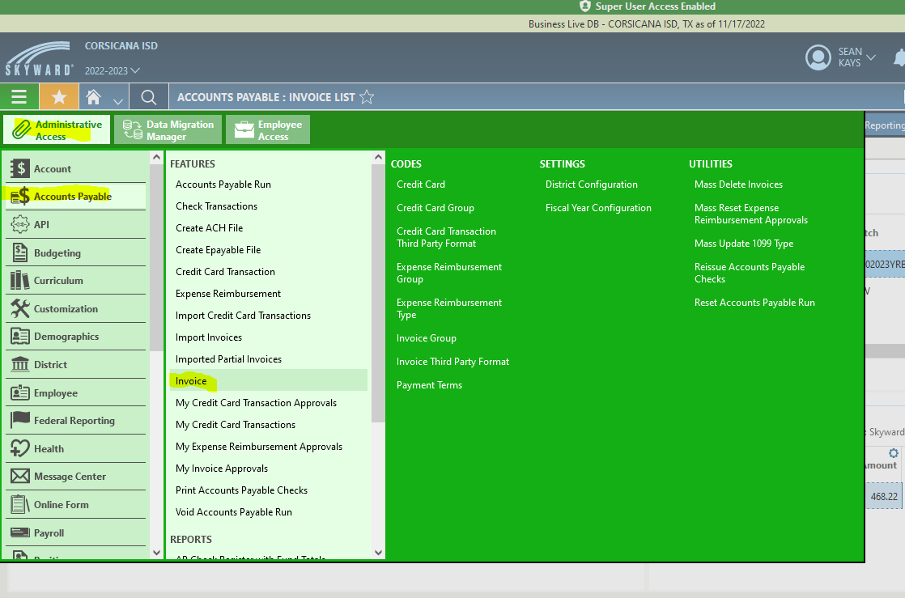
- Add Invoice
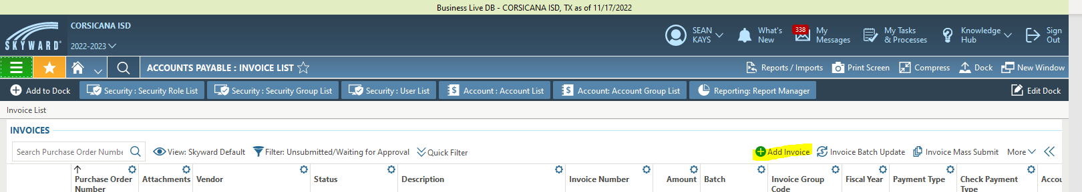

- Scan in invoices and attach by clicking ‘Add Attachments’. Fill in each highlighted area. Be sure to type entire invoice number in the box. If the invoice is attached to a PO, use the drop down menu for purchase orders and click the relevant PO. Keep batch and dates as is. Click Save and Add Detail.

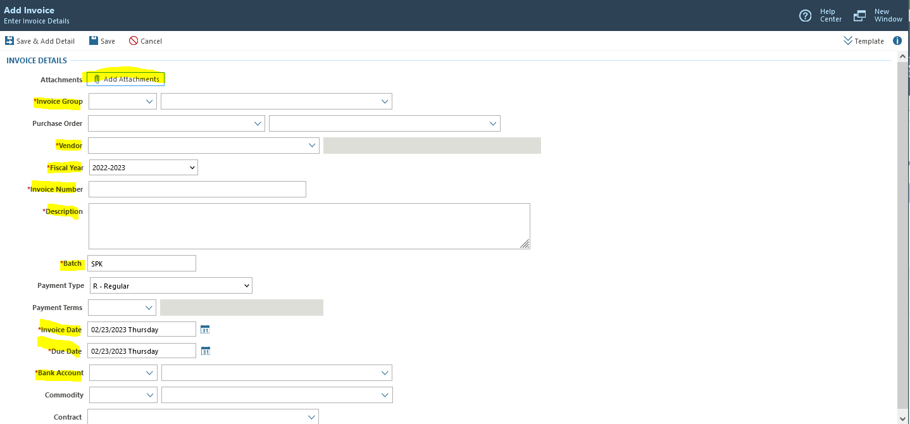

- This is where you add details for the items. If it’s just one item, be specific. Just like POs, if it’s more than three items, quantity is 1 and put the total for the invoice. If it’s less than 3 items, you’ll fill out details for the one item and then click Save and Add another for another item on the SAME invoice. Fill out highlighted areas. When finished, hit ‘Submit and Add New Invoice’ or ‘Submit’. Retain hard copy for yourself.
